Database

# في التخلفات

سؤال رقم 3



# Ahmed.Amr



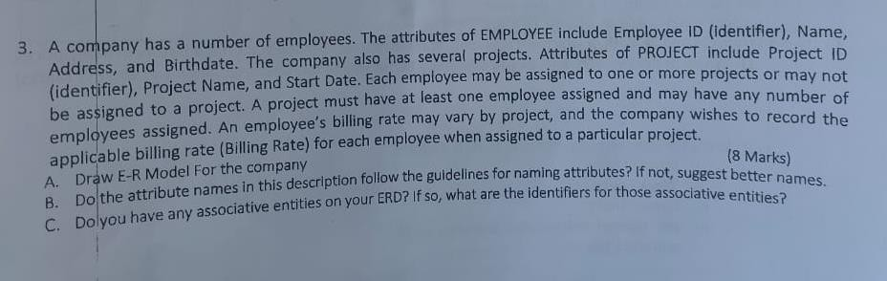

▶ **Given:**



▶ A company has a number of employees. The attributes of FEMPLOYEE include Employee io (identifier), Name, Address, and Birthdate. The company also has several projects. Attributes of (PROJECT include Project ID (identifier), Project Name, and Start Date. Each employee maybe assigned to one or more projects or may not be assigned to a project. A project must have at least one employee assigned and may have any number of employees assigned. An employee's billing rate may vary by project, and the company wishes to record the applicable billing rate (Billing Rate) for each employee when assigned to a particular project.

▶

1. **Draw ER Model For the company**
2. **Do the attribute names in this description follow the guidelines for naming**

attributes? If not, suggest better names.

1. **do you have any associative entities on your ERD? If so, what are the identifiers for those associative entities?**

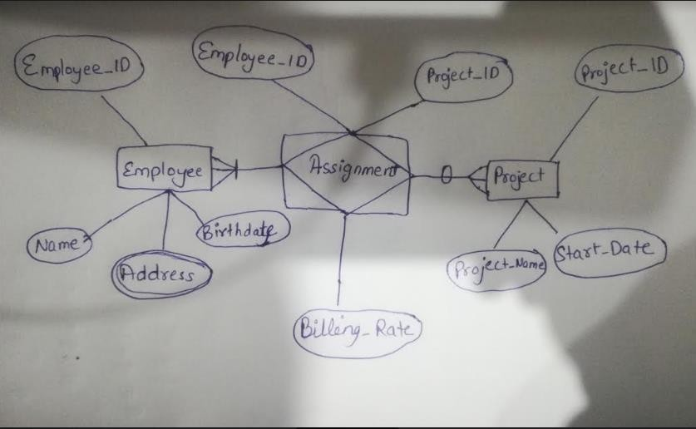



▶ EMPLOYEE table:

▶ Employee_ID (Since attribute names cannot have space. Either an underscore or hyphen must be used)

▶ Name and Address can be used as it is.

▶ Date_of_Birth (Since logical noun should be separated with an underscore)

▶ PROJECT

▶ Project_ID (Since attribute names cannot have space. Either an underscore or hyphen must be used)

▶ Name can be used instead of Project Name

▶ Start_Date (Since space cannot be used)

▶ Rate_of_Billing instead of Billing Rate (Since logical verb or noun must be separated by underscore or hyphen)